**Departmental Profile**

**Department of History**

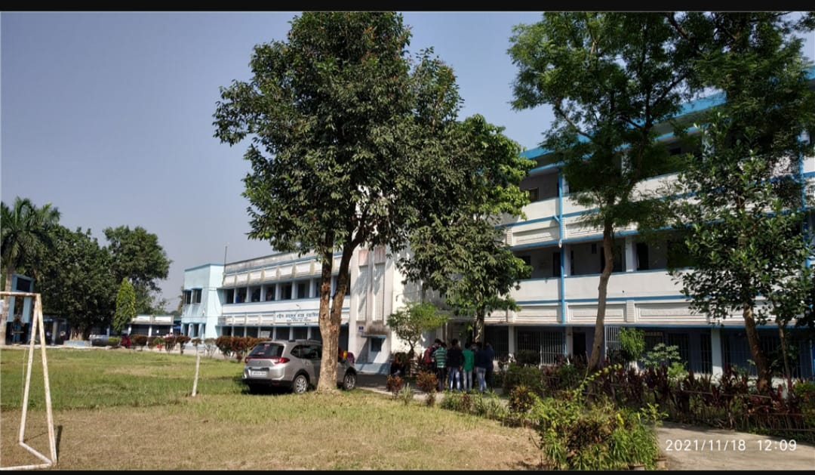

**Saheed Anurup Chandra Mahavidyalaya**

**Burul, South 24 Parganas, 743318**

1. **Establishment of the Department**

The department was established in the year 1991 with General Course after successful running of 5 years, the University of Calcutta has given extension of affiliation in Honours course to our department in the year 1996.

1. **Mission**

* To provide the right ambience and opportunities for the students.
* To provide on environments for critical and innovative thinking and to encourage life long learning.
* To expand the understanding of history within the wider community through projects, outreach, and service activities.
* To develop the skills of analysis and critique, which will assist them in ensuing in various fields such as education, research, public history, and more.

1. **Vision**

To encourage students' interest in the past, develop critical thinking skills, provide a deep understanding of the depth, significance of history, and shape them into well-rounded, responsible citizens through their holistic development.

1. **Faculty profile with name qualification, designation & specialization**

|  |  |  |  |  |
| --- | --- | --- | --- | --- |
| **Name** | **Qualification** | **Designation** | **Specialization** | **No. of years of Experience** |
| Prof. Gopal Deb Kantha | M.A. | Associate Professor | Coins & Epigraph | 35 |
| Prof.Debasish Bera | M.A. | Assistant Professor | Modern & Regional Indian history. | 24 |
| Prof.Karabi Roy | M.A. | SACT (State Aided college Teacher) | Sufism | 28 |
| Prof.Swarup Kumar Das | M.A. | SACT (State Aided college Teacher | Economic History of modern India | 26 |
| Prof.Gautam Mondal | M.A. | SACT (State Aided college Teacher | Early mediaeval period | 15 |

**5. Academic Calendar & semester wise Syllabus cum teaching plan.**

**B.A. First semester History (Honours) Session: 2024 – 2025.**

**Paper Distribution Year 2024 -2025.**

**HISAM**

CC-1 –Debasis Bera

CC-2 -Gopal Deb Kantha/ Goutam Mondal

CC-3-Debasis Bera

CC-4-Gopal Deb Kantha/Goutam Mondal

CC-5 - Debasis Bera

CC-6 Paper- Gopal Deb Kantha/Goutam Mondal

CC-7 -Karabi Roy

CC-- Gopal Deb Kantha/ Goutam Mondal

CC-9 -Karabi Roy

CC-10 -Debasis Bera

CC-11-Gopal Deb Kantha

CC-12 -Swarup Kumar Das

CC-13 -Gopal Deb Kantha

CC-14s- Swarup Kumar Das

**SEC (Skill Enhancement Course)**

SEC – A-1- Swarup Kumar Das

SEC – B-2 - Swarup Kumar Das

DSE (Discipline Specific Elective)

DSE – A-1- Debasis Bera/ Goutam Mondal

DSE -B-1 – Karabi Roy

DSE – A-3- Debasis Bera/ Goutam Mondal

DSE – B-3- Karabi Roy

**MHIS**

CC-1 –Debasis Bera

CC-2 -Gopal Deb Kantha/ Goutam Mondal

CC-3-Debasis Bera

CC-4-Gopal Deb Kantha/Goutam Mondal

CC-5 - Debasis BeraCC-6 Paper- Gopal Deb Kantha/Goutam Mondal

CC-7 -Karabi Roy

CC-8- Gopal Deb Kantha/ Goutam Mondal

**6. Course Structure B.A. History Honours & General (CCF)**

|  |  |  |  |  |  |  |  |  |  |
| --- | --- | --- | --- | --- | --- | --- | --- | --- | --- |
|  | H -CC | Minor  Course | IDC | AEC | SEC | CVAC | Summer Internship | Research Work/ Dissertation | Total Credits |
|  |  |  |  |  |  |  |  |  |  |
| Semesters | 22x 4=88 | 8x4=32 | 3x3=9 | 4x2=8 | 3x4=12 | 4x2=8 | 1x3=3 | (1x4=4)+ (1x8=8)=12 | 172 |
|  |  |  |  |  |  |  |  |  |  |
| Semester-1 | 1x4= 4  3Th+1Tu/ Prac | 1x4= 4 (m1)  3Th+1Tu/ Prac | 1x3= 3  2TH +l P/TU | 1x2= 2  2TH+  0 P/TU | 1x4= 4  2Th+2Tu/ Prac | 2x2 |  |  | 21 |
|  |  |  |  |  |  |  |  |  |  |
| Semester-2 | 1x4= 4  3Th+1Tu/ Prac | 1x4= 4 (m1)  3Th+1Tu/ Prac | 1x3= 3  2TH +l P/TU | 1x2= 2  2TH+  0 P/TU | 1x4= 4  2Th+2Tu/ Prac | 2x2 |  |  | 21 |
|  |  |  |  |  |  |  |  |  |  |
| Semester-3 | 2x4= 8  3Th+1Tu/ Prac | 1x4= 4(m2)  3Th+1Tu/ Prac | 1x3= 3  2TH +l P/TU | 1x2= 2  2TH+  0P/TU | 1x4= 4  2Th+2Tu/ Prac |  |  |  | 21 |
|  |  |  |  |  |  |  |  |  |  |
| Semester-4 | 4x4= 16  3Th+1Tu/ Prac | 1x4= 4(m2)  3Th+1Tu/ Prac |  | 1x2= 2  2TH+  0 P/TU |  |  |  |  | 22 |
|  |  |  |  |  |  |  |  |  |  |
| Semester-5 | 4x4= 16  3Th+1Tu/ Prac | 2x4= 8 m1+m2 3Th+1Tu/ Prac |  |  |  |  |  |  | 24 |
|  |  |  |  |  |  |  |  |  |  |
| Semester-6 | 3x4= 12  3Th+1Tu/ Prac | 2x4=8 m1+m2 3Th+1Tu/ Prac |  |  |  |  | 1x3 |  | 23 |
|  |  |  |  |  |  |  |  |  |  |
| Semester-7 | 4x4= 16  3Th+1Tu/ Prac |  |  |  |  |  |  | 1x4* | 20 |
|  |  |  |  |  |  |  |  |  |  |
| Semester-8 | 3x4= 12  3Th+1Tu/ Prac |  |  |  |  |  |  | 1x8* | 20 |
|  |  |  |  |  |  |  |  |  |  |
| Credits | 22x4= 88 | 8x4= 32 | 3x3= 9 | 4x2= 8 | 3x4= 12 | 4x2= 8 | 1x3=3 | (1x4)+  (1X8)=12 | 172 |
| Marks | 22x100=2200 | 8x100=800 | 3x75=225 | 4x50=200 | 3x100=300 | 4x50=20  0 | 1x 75 | 1x100+  1x200=300 | Total Marks  =4300 |

**7. Discipline- specific Courses H /CC**

HIS-H-CC 1 SEM -1: HISTORY OF INDIA (FROM THE EARLIEST TIMES TO C 300 BCE)

HIS- H -CC 2 SEM-2: SOCIAL FORMATIONS AND CULTURAL PATTERNS OF THE ANCIENT WORLD OTHER THAN INDIA.

HIS- H CC 3 SEM-3: HISTORY OF INDIA (C 300 BCE TO C.750 CE)

HIS- H CC 4 SEM-3: SOCIAL FORMATIONS AND CULTURAL PATTERNS OF THE MEDIEVAL WORLD OTHER THAN INDIA

HIS- H CC 5 SEM-4: HISTORY OF INDIA (C.750 – 1206)

HIS- H CC 6 SEM-4: HISTORY OF EUROPE (C.1453-1650)

HIS- H CC 7 SEM-4: HISTORY OF INDIA (C.1206 – 1526)

HIS- H CC 8 SEM-4: HISTORY OF EUROPE–(C. 1650-1780)

HIS- H CC 9 SEM-5: HISTORY OF INDIA (C.1526-1605)

HIS- H CC 10 SEM-5 HISTORY OF INDIA (C.1605 – 1750)

HIS- H CC 11 SEM-5: HISTORY OF MODERN EUROPE (C.1780-1939)

HIS- H CC 12 SEM-5: HISTORY OF INDIA (C.1750– 1857)

HIS- H CC 13 SEM-6: HISTORY OF INDIA (C. 1857 – 1964)

HIS- H CC 14 SEM-6 : HISTORY OF WORLD POLITICS: (1945-1994)

HIS- H CC 15 SEM- 6: HISTORY OF MODERN EAST ASIA – I CHINA (C.1840 – 1949)

HIS- H CC 1 6 SEM-7: HISTORY OF MODERN EAST ASIA – II JAPAN (C.1868 – 1945)

HIS- H CC 1 7 SEM-7: HISTORY OF BENGAL (C.1757-1905)

HIS- H CC 18 SEM-7: HISTORY OF BENGAL (C.1905-1947)

HIS- H CC 19 SEM -7: WOMEN IN COLONIAL INDIA

HIS- H CC 20 SEM -7: HISTORICAL TOURISM: THEORY &PRACTICE

HIS- H CC 21 SEM -8: MAJOR DEBATES IN HISTORY .

HIS- H CC 22 SEM -8: THEMES IN CONTEMPORARY HISTORY OF INDIA (1947-1991)

HIS- H CC 23 SEM -8: ART APPRECIATION: AN INTRODUCTION TO INDIAN ART.

HIS- H CC 24 SEM -8: HISTORIOGRAPHY AND TOOLS OF HISTORICAL RESEARCH

HIS- H CC 25 SEM -8: NATIONAL LIBERATION MOVEMENTS IN 20TH CENTURY WORLD.

**MINOR COURSES m1m2**

HIS-m1- 1 SEM -1: HISTORY OF INDIA (FROM THE EARLIEST TIMES TO C 300 BCE)

HIS-m1 2 SEM-2: SOCIAL FORMATIONS AND CULTURAL PATTERNS OF THE ANCIENT WORLD OTHER THAN INDIA

HIS-m1 3 SEM-5: HISTORY OF INDIA (C 300 BCE TO C.750 CE)

HIS-m1 4 SEM -6 HISTORY OF EUROPE (C.1453-1650

**INTER DISCIPLINARY COURSES (IDC)**

HIS-IDC-1: Making of Contemporary India (1919 -1964)

SKILL ENHANCEMENT COURSES (SEC )

HIS- SEC-1: SEM -1 Museum and Archives

HIS- SEC-2 SEM -2 Understanding Cultural Heritage and Tourism

HIS- SEC- 3 SEM -3 Understanding Popular Culture of Bengali.

**8. Three Year B.A. Multidisciplinary Courses (General)**

|  |  |  |  |  |  |  |  |  |  |
| --- | --- | --- | --- | --- | --- | --- | --- | --- | --- |
| Course Structure - MDC | | | | | | | | | |
|  | CC1 | CC2 | Minor | IDC | AEC | SEC | CVAC | Summer Internshi p | Tot al Cre  dit |
| Semester | 8x4= 32 | 8x4= 32 | 6x4= 24 | 3x3=9 | 4x2= 8 | 3x4=12 | 4x2=8 | 1x3= 3 | 125 |
|  |  |  |  |  |  |  |  |  |  |
| 1 | 1x4= 4  3TH+  1P/TU | 1x4= 4  3TH+  1P/TU |  | 1x3=3  2TH  +1P/TU | 1x2= 2  2TH  +0P/TU | 1x4= 4 | 2x2=4 |  | 21 |
|  |  |  |  |  |  |  |  |  |  |
| 2 | 1x4= 4  3TH+  1P/TU | 1x4= 4  3TH+  1P/TU |  | 1x3=3  2TH  +1P/TU | 1x2= 2  2TH  +0P/TU | 1x4= 4 | 2x2=4 |  | 21 |
|  |  |  |  |  |  |  |  |  |  |
| 3 | 1x4= 4  (3TH+ 1P/TU) | 1x4= 4  3TH+  1P/TU | 1x4= 4  3TH+1P/TU | 1x3=3  2TH  +1P/TU | 1x2= 2  2TH  +0P/TU | 1x4= 4 |  |  | 21 |
|  |  |  |  |  |  |  |  |  |  |
| 4 | 2x4=8  4x(3TH+  1P/TU) | 2x4= 8  2x(3TH+  1P/TU | 1x4= 4 (3TH+1P/TU) |  | 1x2= 2  2TH  +0P/TU |  |  |  | 22 |
|  |  |  |  |  |  |  |  |  |  |
| 5 | 2x4= 8  2x(3TH+  1P/TU) | 1x4= 4  3TH+  1P/TU | 2x4= 8  2x(3TH+  1P/TU |  |  |  |  |  | 20 |
|  |  |  |  |  |  |  |  |  |  |
| 6 | 1x4= 4  (3TH+ 1P/TU) | 2x4= 8  2x(3TH+  1P/TU) | 2x4= 8  2x(3TH+  1P/TU) |  |  |  |  |  | 20 |
|  |  |  |  |  |  |  |  |  |  |
| Credits | 8x4= 32 | 8x4= 32 | 6x4= 24 | 3x3= 9 | 4x2= 8 | 3x4= 12 | 4x2=  8 |  | 125+3  =128 |
| Marks | 8x100=  800 | 8x100=  800 | 6x100=  600 | 3x75=  225 | 4x50=  200 | 3x100=  300 | 4x50=  200 |  | Total  MarKs  =3200 |

**Multi-Disciplinary Core Courses in History MD -CC Each Course: 4 Credits**

HIS- MD- CC 1 SEM -1: HISTORY OF INDIA (FROM THE EARLIEST TIMES TO C 300 BCE)

HIS - MD-CC 2 SEM-2: SOCIAL FORMATIONS AND CULTURAL PATTERNS OF THE ANCIENT WORLD OTHER THAN INDIA.

HIS- MD- CC 3 SEM-3: HISTORY OF INDIA (C 300 BCE TO C.750 CE)

HIS - MD-CC 4 SEM -4: HISTORY OF EUROPE (C.1453-1650)

HIS- MD- CC 5 SEM-4: HISTORY OF INDIA (C.1206 – 1526)

HIS - MD-CC 6 SEM-5: HISTORY OF INDIA (C.1526-1605)

HIS- MD- CC 7 SEM-5: HISTORY OF MODERN EUROPE (C.1780-1939)

HIS- MD- CC 8 SEM -6: HISTORY OF INDIA (C.1750s– 1857)

**9. Pass Percentage C.U. Examination Pass out Students**

|  |  |  |  |
| --- | --- | --- | --- |
| Session | Appeared | Passed | Percentage |
| 2018-19 | 31 | 30 | 96.77 |
| 2019-20 | 23 | 23 | 100 |
| 2020-21 | 22 | 22 | 100 |
| 2021-22 | 32 | 32 | 100 |
| 2022-23 | 21 | 20 | 95.23 |
| 2023-24 | 25 | 23 | 92 |

**10. Seminars/Workshop/ Organised by the Department**

|  |  |  |  |
| --- | --- | --- | --- |
| **Topic** | **Year** | **International/National/State Level** | **Speaker** |
| ‘Liberation War of Bangladesh: National & International Perspective’ | 2020 | International | Dr. Ashis Kumar Das  Dr. Md. Abdur Rahim  Dr. Md. Humayun Kabir |
| ‘Skill Enhancement: With Spcial Reference of Temple Architecture and Historical Communique’ | 2023 | State | Dr. Amrita Chakraborty  Dr. Swagata Gupta |

**11. Field Work Organised by the Department**

|  |  |  |  |
| --- | --- | --- | --- |
| **Topic** | **Place** | **date** | **Teachers Present** |
| Understanding Heritage | Falta Fort | 20.07.2024 | Prof. Gopal Deb Kantha  Prof. Debashis Bera  Prof. Karabi Roy  Prof. Swarup Kumar Das |
| Archives and Museum | Behala Museum | 30.11.2023 | Prof. Gopal Deb Kantha  Prof. Debashis Bera  Prof. Karabi Roy  Prof. Swarup Kumar Das  Prof. Goutam mondal |
| Understanding Heritage | Chandraketu Garh | 13.05.2023 | Prof. Swarup Kumar Das  Prof. Goutam mondal |
| Archives and Museum | Indian Museum, Kolkata | 18.11.2022 | Prof. Gopal Deb Kantha  Prof. Debashis Bera  Prof. Karabi Roy  Prof. Swarup Kumar Das  Prof. Goutam mondal |
| Understanding Heritage | Indian Museum, Kolkata | 15.05.2022 | Prof. Gopal Deb Kantha  Prof. Debashis Bera  Prof. Karabi Roy  Prof. Swarup Kumar Das  Prof. Goutam mondal |
| Understanding Heritage | Naldari Ghat, Burul | 22.05.2023 | Prof. Swarup Kumar Das |
| Understanding Heritage | Bawali Rajbari | 25.05.2023 | Prof. Swarup Kumar Das |
| Archives and Museum | Indian Museum, Kolkata | 18.05.2018 | Prof. Gopal Deb Kantha  Prof. Debashis Bera  Prof. Karabi Roy  Prof. Swarup Kumar Das  Prof. Goutam mondal |

**12. Participation in Institutional Social Responsibility (ISR) and Extension Activities:**

* Student and Teachers Participate in the Following Programmes/Extension Activities.
* Blood Donation
* Raksha Bandhan
* Teacher’s Day Programme
* Republic Day
* Netaji Subhas Chandra Bose Birth Day
* Independence Day
* Bhasa Divas
* World Environmental Day

**13. Library**

* We have our central library for all students and faculty members.
* Students of Honours course are given open access to the library.
* Our department keeps all books purchase records and update regularly for availability of books.
* We have 3088 number of total books in central library (as per library record) with the number of text book 1651 and number of reference books 1437.

**14. Strength**

* The department has to its credit a number of publications of wall magazines.
* Library with latest book’
* ICT enabled Teaching Method.
* Good relationship between teachers and students.
* Regular educational tour as component of the syllabus.
* A good number of our successful students have taken admission in post graduate course.
* Students participate in sports and cultural activities organized by the college.
* The students also participate in seminars and workshops organized by different institutions to be aware of the latest academic and technical issues related to different branches of History.
* Students are very much enthusiastic in participate in different programmes on sports, cultural activities, NSS, NCC etc.

**15. Weakness**

* Though students of our department came with good academic record, most of them are from economically poor family, so they discontinue the students for various family problems.
* Dearth of space in the department.
* In sufficient full time teaching faculty.
* Unavailability of quality students from feeder school.

**16. Teaching Methods**

* Classroom lecture
* Tutorial classes
* Students’ seminar and group discussion
* Power point presentation (ppt)
* Project work
* Special lectures by eminent academicians
* Audio visual screening

**17. Job Prospect**

* Many students pursue higher studies and complete their post-graduation.
* A number of students are employed in school service commission.
* Many students of our department are presently serving in various government and private sectors such as banking, healthcare, media and marketing.
* Many studs get job from Bajaj Employability Training programme in our Department.

**18. Future Plans**

* Intermate facility in the department as well as library for the students,
* Organised Question answer workshop.
* We plan to keep contact with our students through college website and whatsaap 24*7.
* Collection of student’s feedback.

**Student’s Activities 2018-2024**

**Visit to Indian Museum 03.07.2024**

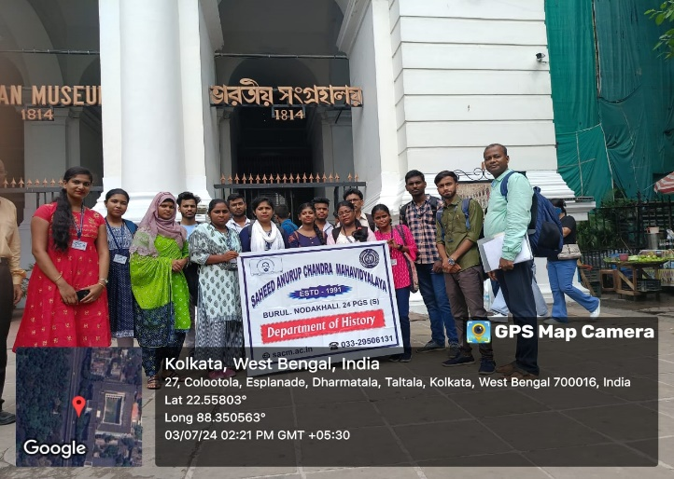

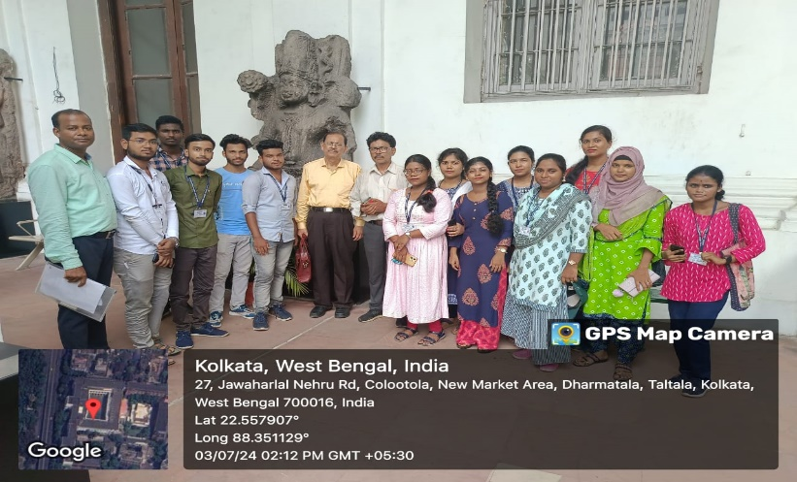

**Visit to Behala Museum 30.11.2023**

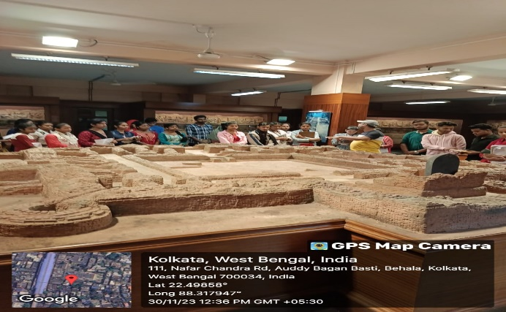

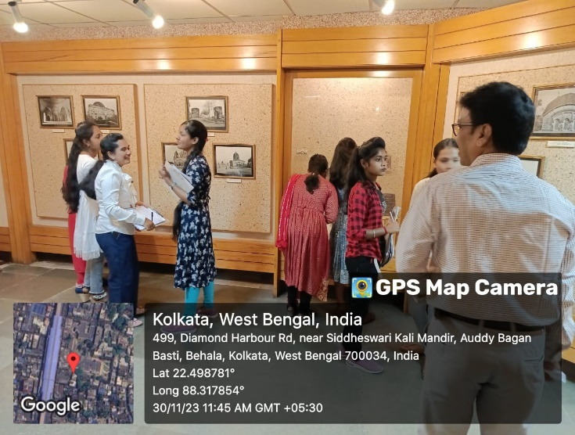

**Visit to Indian Museum 18.11.2022**

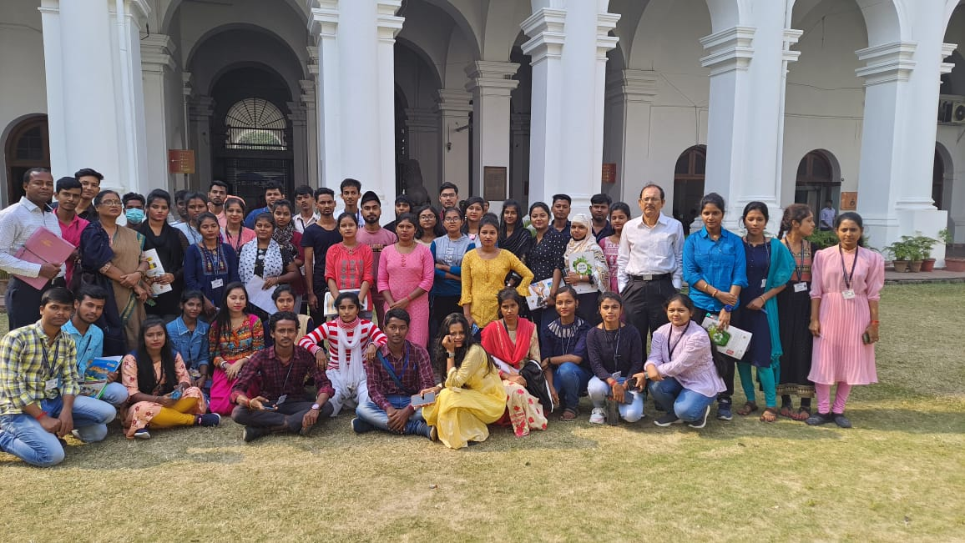

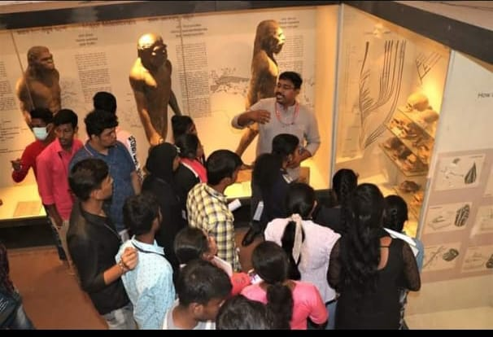

**Visit to Chandraketu Garh 13.05.2023**

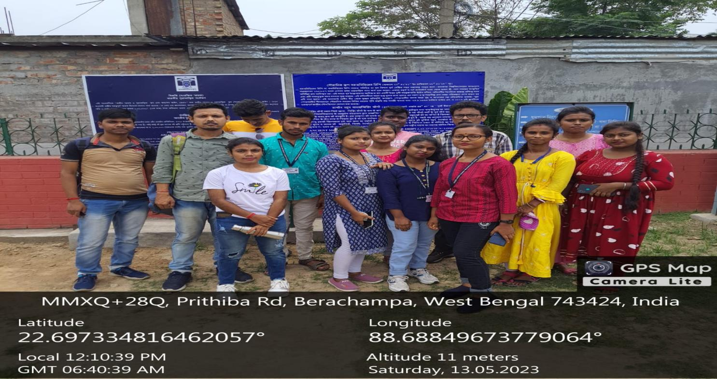

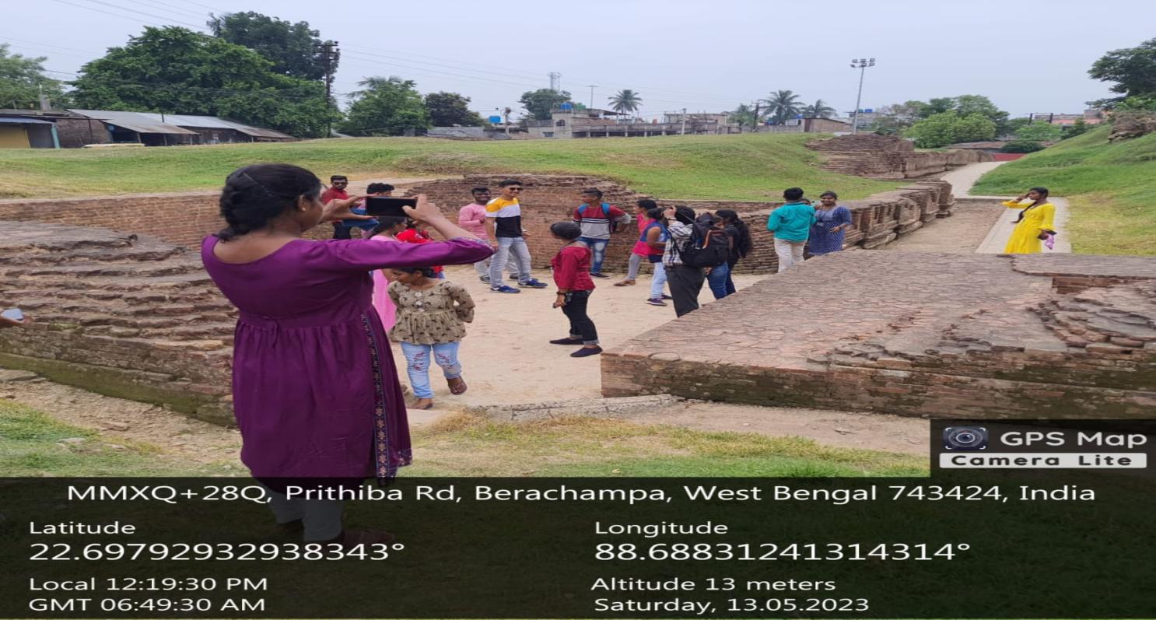

**Visit to Naldanri Ghat, 2023**

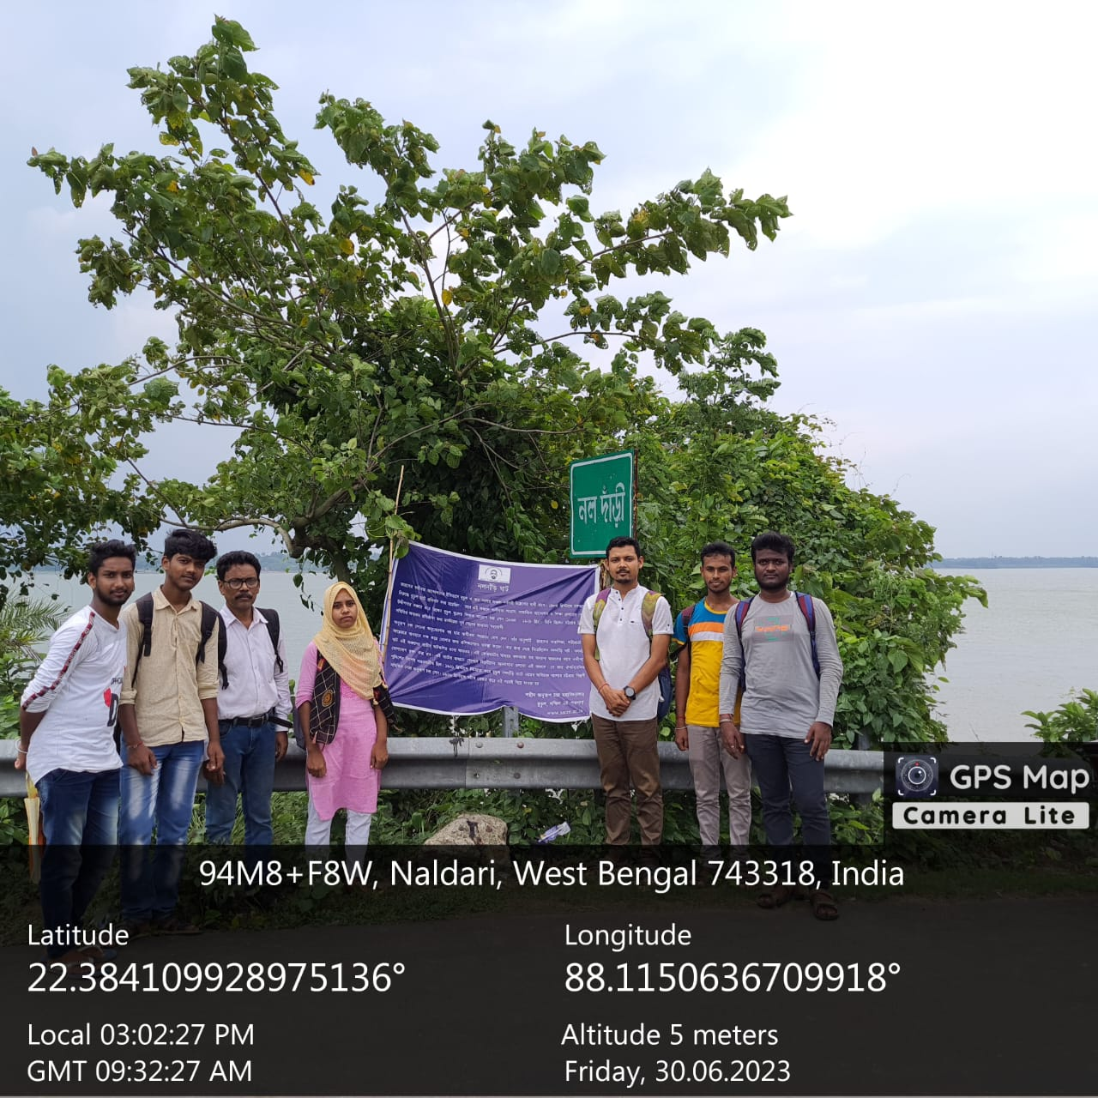

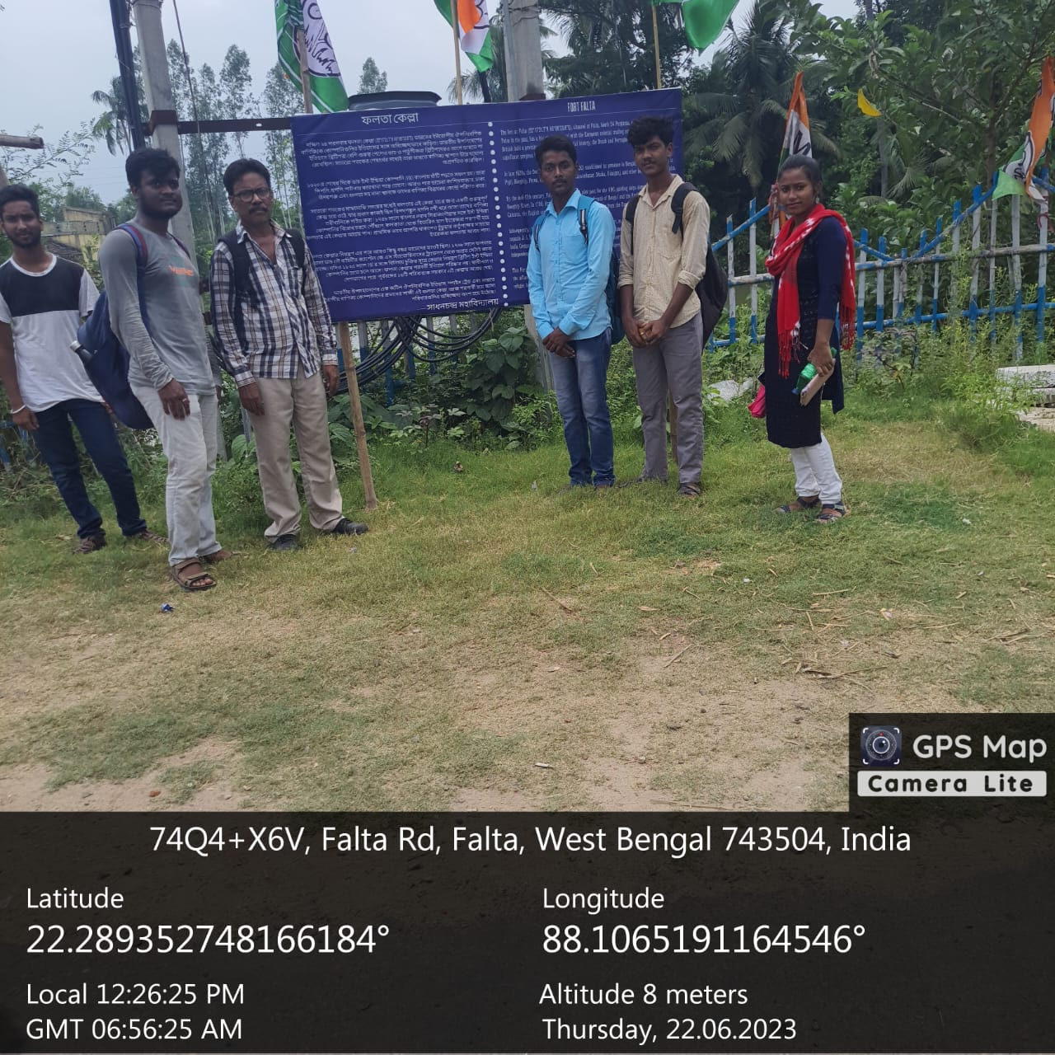

**Visit to Bawali Rajbari, 2023**

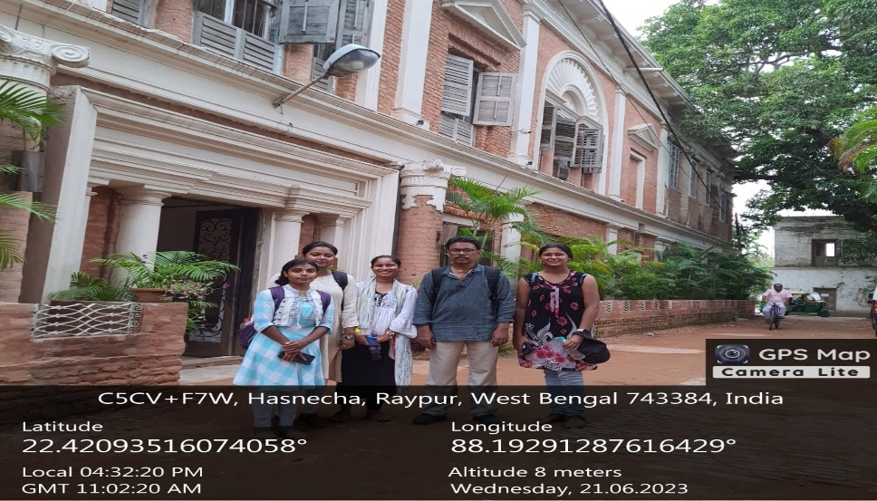

**Departmental Meeting, 2024**

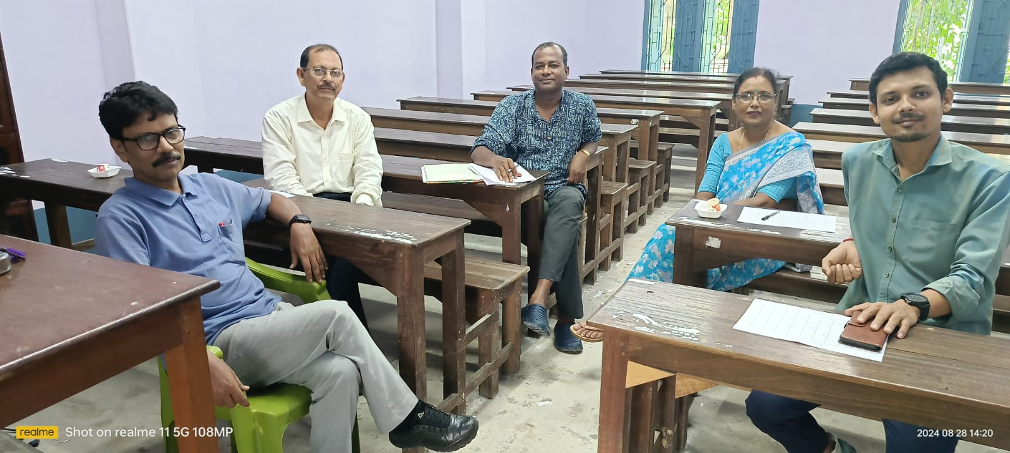

**Visit to Local Temple,2023**

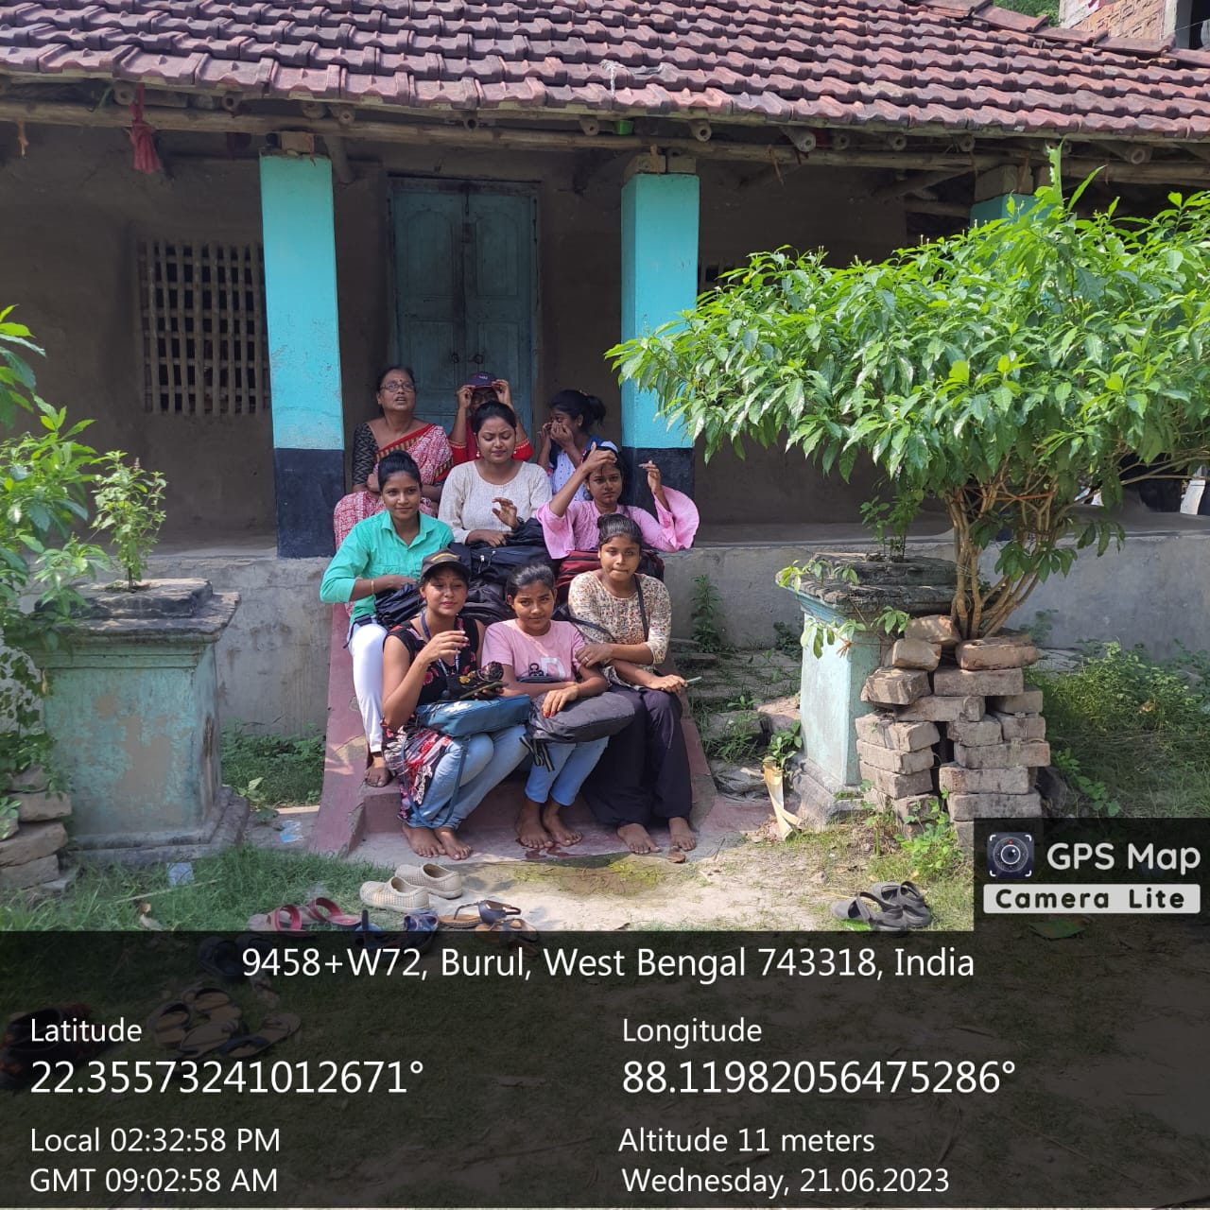

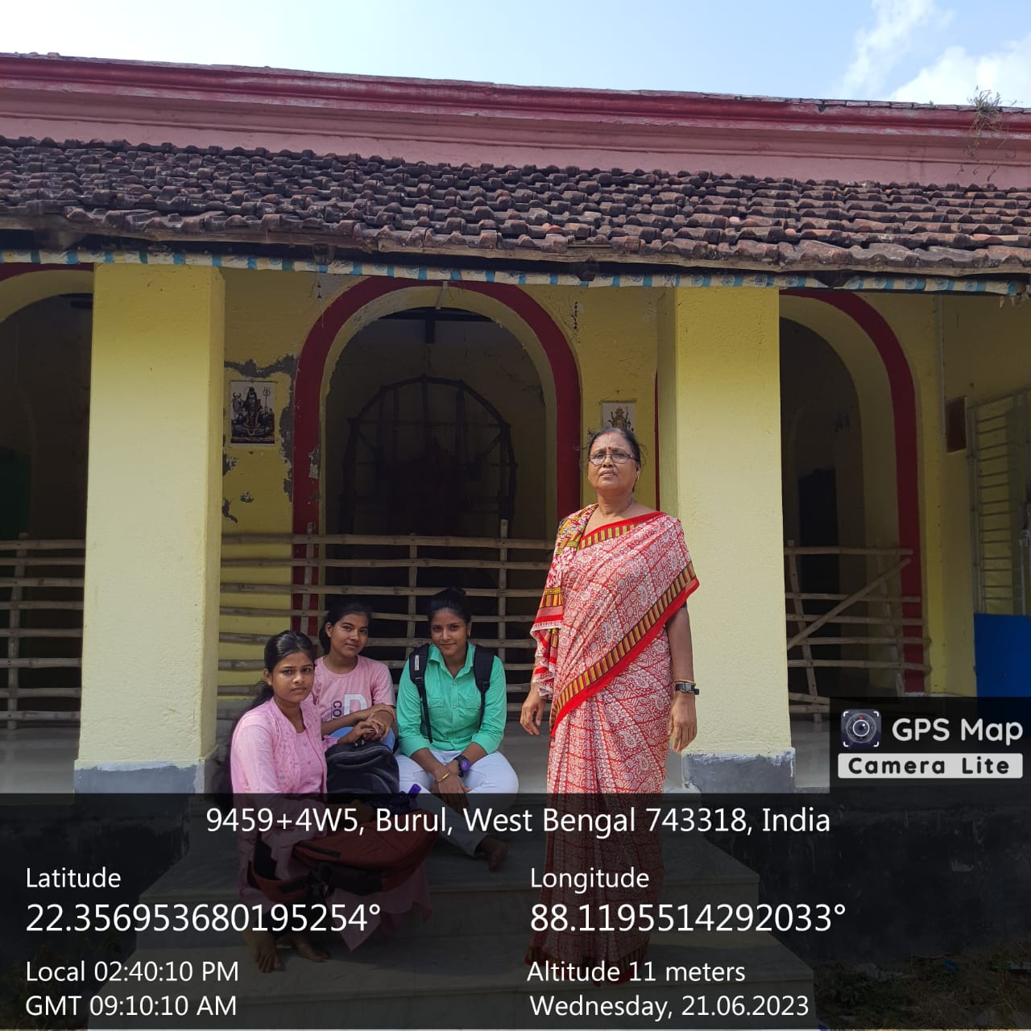

**Student Activities, 2018-24**

